PROJECT PROPOSAL

NIHVA TECHNOLOGIES PVT. LTD.
187, G-Block, Thermax chowk, Above Renault Showroom, MIDC
Chinchwad, Pune – 411019.

Customer Name | IKEA
Project Name | NIHVA Dock Leveler
Project Location | Pune
Contact Person Name | Mr. Rahul Borate
Email Id | rahul.borate@ingka.ikea.com
Contact Number | 7020097007
Date | 23.09.2019

Contact Person: Ms. Varsha
Mob No.: 8551091333
Email id: support@nihva.com
Web: http://www.nihva.com

NIHVA – Dock Leveler

Purpose of Dock Leveler: –

A dock leveler is a piece of equipment that is usually either mounted to the dock face or recessed into a pit at a loading dock door allowing movement of industrial vehicles between a building and a transport vehicle.

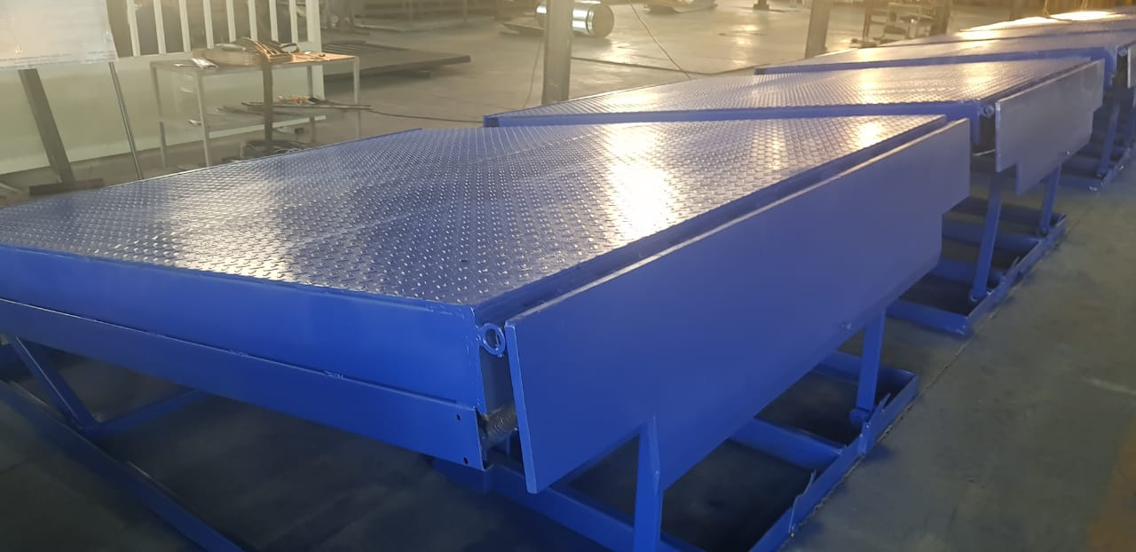

INTRODUCTION: -

Dock Leveler is a height-adjustable platform used to ensure smooth transition between dock and truck which helps prevent forklift accidents that can cause serious injuries and forklift damages. It is usually comprised of a simple metal plate that is raised from a stowed position and then lowered onto the back of the truck.
NIHVA Dock Levelers are designed according to Indian Conditions. Dock Levelers not only help into loading & Unloading of vehicles easily but also reducing the dispatch time of vehicles significantly

Key Features of NIHVA Dock Levelers are as follows:
- Robust Design, safe operations & long-term reliability
- Total Control on basic hydraulic like pressure & flow
- Velocity Safety Stops
- Simple electric panel with push button
- Priority to safe working operations
- Long excellent stability
- Consistency in working performance
Few Images of NIHVA Dock Leveler:

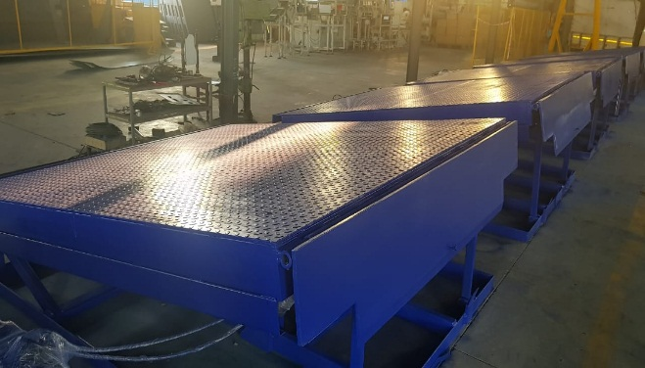
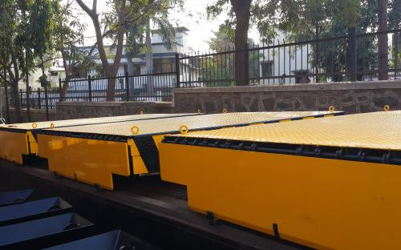

Technical Specifications: -

Sr. No. | Description | Specifications
1 | Capacity | 9 Ton
2 | Dock operation mode | AC power pack hydraulically operated
3 | Lip operation mode | Hydraulic
4 | Operation control | Through panel
5 | Loading platform height from road | 4 Ft
6 | Travel above & below dock level | (+) 300 / (-) 200 mm
7 | Platform Size (W x L) | 2200 mm x 2450 mm
8 | Lip size (W x L ) | 2200 x 400 mm
9 | Dock Leveller (Shut) Height | 480 mm
10 | Working length | 2850 mm
11 | Overall length | 2200mm x 2450mm + Lip Length (400mm )
12 | Deck Plate (MS Chequered) | 8 mm Thick
13 | Lip Plate | 16 mm Thick
14 | Maximum slope can be achieved | 10%
15 | Clear Pit dimensions (W x L x D) | (W) 2250 mm x (L) 2500 mm x (D) 485 mm
16 | Driver type | Direct by electric Motor
17 | Motor Ratings | 1 H.P Motor
18 | Pump design flow | 2.8 LPM
19 | Pump pressure | 120 bar Operating 200 bar Max.
20 | Safety valve set pressure | 120 Kg/cm²
21 | Pump Type | Gear
22 | No Of Deck cylinder | 2 Nos
23 | Lip Cylinder | 1 No
24 | Dock Bumper | Included - 1 pair
Commercial Offer: -
Sr. No | Description | Qty in no’s | Rate In INR | Net Amount
1 | NIHVA Dock Leveler (Supply + Installation + Transportation)  2 cylinders for Deck & 1 cylinder for LIP Operator by Standard Control Panel (Deck Up / Down / Lip Up / Down) Rubber Bumpers.  Size: (W) 2200 mm X (H) 2450 mm  Capacity 9 Ton | 1 | 2,10,000 | 2,10,000
2 | Traffic Signaling System = Rs. 10,000  Flashing Light as per Agreement = Rs. 7,000  ( Rs 10,000 – Rs 7,000 ) = Rs 3,000 | 1 | 3,000 | 3,000
 | Total |  |  | 2,13,000
Terms and Conditions: -
- Price : FOR SIte

- P & F : Nil

- Freight Notes : Mentioned as above

- Delivery : Within 6 - 7 weeks from date of receipt of confirmed purchase order, advance payment, drawing approval.

- Payment Terms : 80% advance along with confirmed purchase order balance before dispatch.

- Insurance : Extra as applicable.

- GST : Extra @ 18%.

- Validity : 15 days from date of quotation.

- Warranty : 12 months from date of supply.

Please feel free to Contact Mr. Vijay Tarak on 0855109333 for any further Clarification in this Concern.
Ms. Varsha
Mob No.: 8551091333
Email id: support@nihva.com
Web: http://www.nihva.com

